### 什么是pv ，uv

（1）PV（page view）

浏览量和访问次数是呼应的。用户访问网站时每打开一个页面，就记为1个PV。同一个页面被访问多次，浏览量也会累积。一个网站的浏览量越高，说明这个网站的知名度越高，内容越受用户喜欢。一味地重视PV也是没有太大意义的（PV跟点击量差不多吧）。

PV是一个重要的指标，反映了网站内容是否对用户有足够的吸引力。对于竞价而言，只能是侧面反映，因为我们设置了访问URL。很多用户需求也非常明确，来到网站之后，往往只会寻找自己需求的产品，所以一味地重视PV也是没有太大意义的。应该把重点内容展示给目标客户就可以了，就没必要一味地追求PV值，追求那些转化率、跳出率、UV、转化次数等那才是重点。

（2）UV（Unique Visitor）

指独立访客访问数，统计1天内访问某站点的用户数(以 cookie 为依据)，一台电脑终端为一个访客。可以理解成访问某网站的电脑的数量。网站判断来访电脑的身份是通过来访电脑的 cookies 实现的。如果更换了 IP 后但不清除 cookies，再访问相同网站，该网站的统计中 UV 数是不变的。

访问日志数据

192.168.8.5 [01/May/2019:12:12:19 +0800] "GET / HTTP/1.1" 200 45 http://www.zr.com/sport/a.html

192.168.8.5 [01/May/2019:12:21:15 +0800] "GET / HTTP/1.1" 200 45 http://www.zr.com/sport/a.html

192.168.8.5 [01/May/2019:12:21:19 +0800] "GET / HTTP/1.1" 200 45 http://www.zr.com/sport/b.html

192.168.8.15 [01/May/2019:12:21:19 +0800] "GET / HTTP/1.1" 200 45 http://www.zr.com/news/a.html

192.168.8.15 [01/May/2019:12:21:22 +0800] "GET / HTTP/1.1" 200 45 http://www.zr.com/news/b.html

192.168.8.15 [01/May/2019:12:20:19 +0800] "GET / HTTP/1.1" 200 45 http://www.zr.com/news/b.html

192.168.8.55 [01/May/2019:12:21:19 +0800] "GET / HTTP/1.1" 200 45 http://www.zr.com/music/a.html

192.168.8.55 [01/May/2019:12:21:25 +0800] "GET / HTTP/1.1" 200 45 http://www.zr.com/music/a.html

### 开发

#### Pv

**package** com.a;  
  
**import** org.apache.flink.api.common.functions.MapFunction;  
**import** org.apache.flink.api.java.tuple.Tuple3;  
**import** org.apache.flink.streaming.api.TimeCharacteristic;  
**import** org.apache.flink.streaming.api.datastream.DataStream;  
**import** org.apache.flink.streaming.api.datastream.SingleOutputStreamOperator;  
**import** org.apache.flink.streaming.api.environment.StreamExecutionEnvironment;  
**import** org.apache.flink.streaming.api.functions.timestamps.BoundedOutOfOrdernessTimestampExtractor;  
**import** org.apache.flink.streaming.api.windowing.assigners.SlidingEventTimeWindows;  
**import** org.apache.flink.streaming.api.windowing.time.Time;  
  
**import** java.text.SimpleDateFormat;  
**import** java.util.Calendar;  
**import** java.util.Locale;  
  
**public class** pv1 {  
 **public static void** main(String[] args)**throws** Exception {  
 StreamExecutionEnvironment env = StreamExecutionEnvironment.*getExecutionEnvironment*();  
 env.setStreamTimeCharacteristic(TimeCharacteristic.***EventTime***);  
  
 DataStream<Tuple3<String, Long, Integer>> s1 = env.socketTextStream(**"192.168.8.66"**, 9999)  
 .map(**new** MapFunction<String, Tuple3<String, Long, Integer>>() {  
 @Override  
 **public** Tuple3<String, Long, Integer> map(String s) **throws** Exception {  
 String a2 = s.split(**" "**)[1].substring(1);  
 Calendar cc = Calendar.*getInstance*();  
 cc.setTime(**new** SimpleDateFormat(**"d/MMM/yyyy:h:m:s"**, Locale.***ENGLISH***).parse(a2));  
 Long a3 = cc.getTimeInMillis();  
 *//System.out.println(a3);* **return new** Tuple3<>(**"pv"**, a3, 1);  
 }  
 });  
 DataStream<Tuple3<String, Long, Integer>> s2 = s1.assignTimestampsAndWatermarks(  
 **new** BoundedOutOfOrdernessTimestampExtractor<Tuple3<String, Long, Integer>>(Time.*seconds*(5L)) {  
 @Override  
 **public long** extractTimestamp(Tuple3<String, Long, Integer> stringLongIntegerTuple3) {  
 **return** stringLongIntegerTuple3.**f1**;  
 }  
 }  
 ).keyBy(0)  
 .window(SlidingEventTimeWindows.*of*(Time.*hours*(1L), Time.*seconds*(60L)))  
 .sum(2);  
 s2.print();  
 env.execute(**"pv"**);  
 }  
}

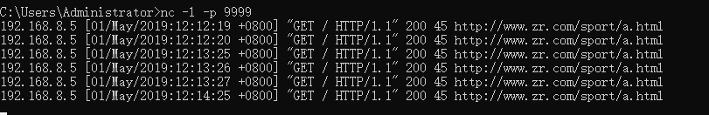

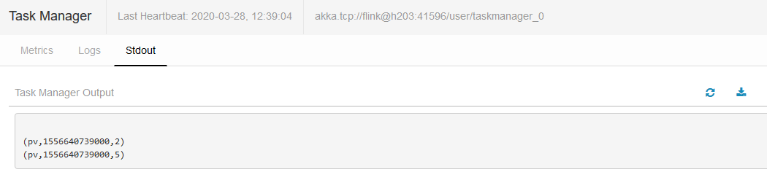

#### UV

**package** com.a;  
  
**import** org.apache.flink.api.common.functions.MapFunction;  
**import** org.apache.flink.api.java.tuple.Tuple3;  
**import** org.apache.flink.streaming.api.TimeCharacteristic;  
**import** org.apache.flink.streaming.api.datastream.DataStream;  
**import** org.apache.flink.streaming.api.datastream.SingleOutputStreamOperator;  
**import** org.apache.flink.streaming.api.environment.StreamExecutionEnvironment;  
**import** org.apache.flink.streaming.api.functions.timestamps.BoundedOutOfOrdernessTimestampExtractor;  
**import** org.apache.flink.streaming.api.windowing.assigners.TumblingEventTimeWindows;  
**import** org.apache.flink.streaming.api.windowing.time.Time;  
  
**import** java.text.SimpleDateFormat;  
**import** java.util.Calendar;  
**import** java.util.Locale;  
  
**public class** uv1 {  
 **public static void** main(String[] args)**throws** Exception{  
 StreamExecutionEnvironment env = StreamExecutionEnvironment.*getExecutionEnvironment*();  
 env.setStreamTimeCharacteristic(TimeCharacteristic.***EventTime***);  
  
 DataStream<Tuple3<String, Long, Integer>> s1 = env.socketTextStream(**"192.168.8.66"**, 9999).map(**new** MapFunction<String, Tuple3<String, Long, Integer>>() {  
 @Override  
 **public** Tuple3<String, Long, Integer> map(String s) **throws** Exception {  
 String a1 = s.split(**" "**)[0];  
 String a2 = s.split(**" "**)[1].substring(1);  
 Calendar cc = Calendar.*getInstance*();  
 cc.setTime(**new** SimpleDateFormat(**"d/MMM/yyyy:h:m:s"**, Locale.***ENGLISH***).parse(a2));  
 Long a3 = cc.getTimeInMillis();  
 *//System.out.println(a3);* **return new** Tuple3<>(a1, a3, 1);  
 }  
 });  
  
  
 DataStream<Tuple3<String,Long,Integer>> s11 = s1.assignTimestampsAndWatermarks(  
 **new** BoundedOutOfOrdernessTimestampExtractor<Tuple3<String, Long, Integer>>(Time.*seconds*(10)) {  
 @Override  
 **public long** extractTimestamp(Tuple3<String, Long, Integer> element) {  
 **return** element.**f1**; }  
 }  
 ).keyBy(0).window(TumblingEventTimeWindows.*of*(Time.*hours*(1L)))  
 .sum(2);  
  
 SingleOutputStreamOperator<Tuple3<String, Long, Integer>> s12 = s11.map(**new** MapFunction<Tuple3<String, Long, Integer>, Tuple3<String, Long, Integer>>() {  
 @Override  
 **public** Tuple3<String, Long, Integer> map(Tuple3<String, Long, Integer> stringLongIntegerTuple3) **throws** Exception {  
 String u1 = **"uv"**;  
 **int** u3 = 1;  
 **return new** Tuple3<String, Long, Integer>(u1, stringLongIntegerTuple3.**f1**, u3);  
 }  
 }).keyBy(0).sum(2);  
 s12.print();  
 env.execute(**"uv"**);  
 }  
}